IT13: ADBMS
Practical Assignment 2 Solution Template
Roll No:-2601089
Name: -Vaishnavi Kagale
_____________________________________________________________________________
Practical 2: Implementation of different types of functions with suitable examples.
- Number Function
- Aggregate Function
- Character Function
- Conversion Function
- Date Function
LAB PRACTICE ASSIGNMENT:
Create a table EMPLOYEE with the following schema:
(Emp_no, E_name, E_address, E_ph_no, Dept_no, Dept_name,Job_id, Designation, Salary)
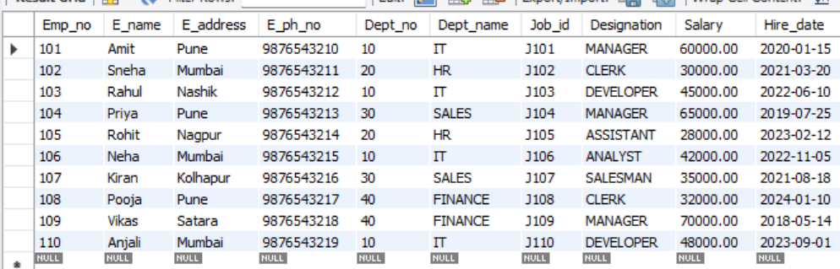
Write SQL statements for the following queries.
- List the E_no, E_name, Salary of all employees working for MANAGER.
SELECT Emp_no, E_name, Salary
FROM EMPLOYEE
WHERE Designation = 'MANAGER';
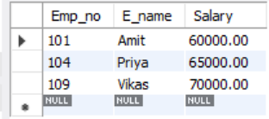
- Display all the details of the employee whose salary is more than 10000.
SELECT * FROM EMPLOYEE WHERE Salary > 10000;

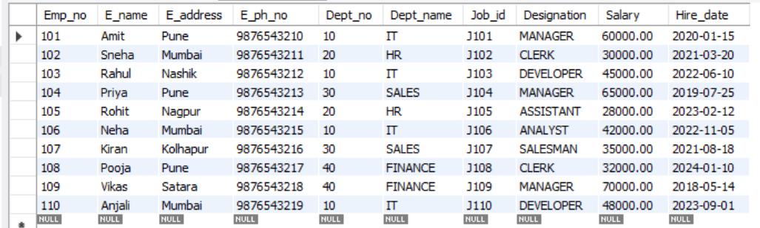
- List the employees in ascending order of Designations of those who joined after 1981.
SELECT * FROM EMPLOYEE WHERE YEAR(Hire_date) > 1981
ORDER BY Designation ASC;
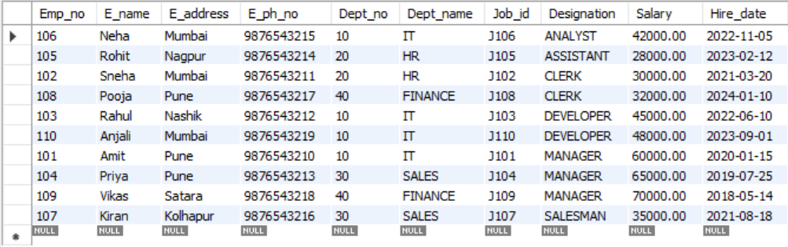
- List the employees along with their Experience and Daily Salary.
SELECT E_name, YEAR(CURDATE()) - YEAR(Hire_date) AS Experience,Salary / 30 AS Daily_Salary FROM EMPLOYEE;
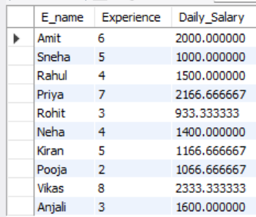
- List the employees who are either ‘CLERK’ or ‘ANALYST '.

SELECT * FROM EMPLOYEE WHERE Designation = 'CLERK' OR Designation = 'ANALYST';
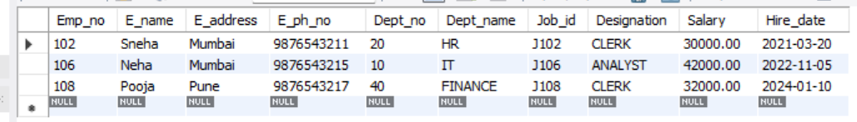
- List the employees who joined on 1-MAY-1981, 3-DEC-1981, 17-DEC-1981, 19-JAN-1980.
SELECT * FROM EMPLOYEE
WHERE Hire_date IN (
'1981-05-01',
'1981-12-03',
'1981-12-17',
'1980-01-19');
- List the employees who are working for Deptno 10 or20.

SELECT * FROM EMPLOYEE WHERE Dept_no = 10 OR Dept_no = 20;
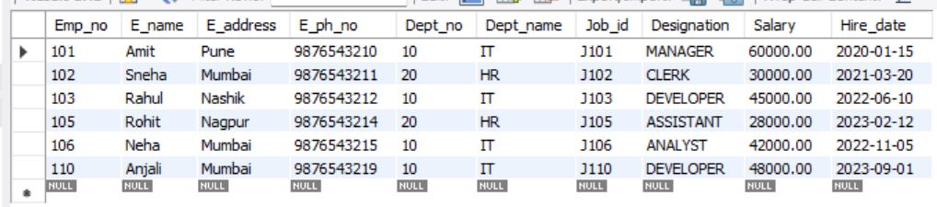
- List the Enames that start with ‘S’.

SELECT E_name FROM EMPLOYEE WHERE E_name LIKE 'S%';
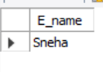
- Write a SQL query to find the highest salary. Return the highest salary
SELECT MAX(Salary) AS Highest_Salary FROM EMPLOYEE;
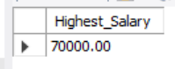
- Display the name and the first five characters of the name starting with ‘H’. List all the employees except ‘PRESIDENT’ & ‘MGR” in ascending order of Salaries.

SELECT E_name, LEFT(E_name, 5) AS First_Five_Characters, Salary FROM EMPLOYEE
WHERE E_name LIKE 'H%' AND Designation NOT IN ('PRESIDENT', 'MGR')
ORDER BY Salary ASC;
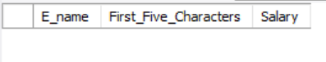
- Display the minimum and maximum salary and Experience of the employee.

SELECT MIN(Salary) AS Minimum_Salary,MAX(Salary) AS Maximum_Salary,
MIN(YEAR(CURDATE()) - YEAR(Hire_date)) AS Minimum_Experience,
MAX(YEAR(CURDATE()) - YEAR(Hire_date)) AS Maximum_Experience
FROM EMPLOYEE;

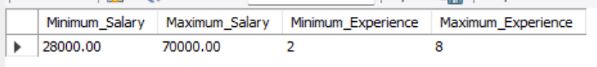
- Display the total salary of all employees.

SELECT SUM(Salary) AS Total_Salary FROM EMPLOYEE;
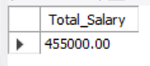
- Write a query to display the average salary of employees working in IT department.

SELECT AVG(Salary) AS Average_Salary FROM EMPLOYEE
WHERE Dept_name = 'IT';

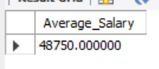

- Display the Distinct salary of an employee.

SELECT DISTINCT Salary FROM EMPLOYEE;
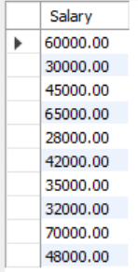
- Drop the database.

DROP DATABASE assignment_2;
